**Senior Falls Prevention Workshop for Service Providers**

**January 24, 2018**

8:30 AM – 1:00 PM

Red Deer

County Centre

38106 RR 275

Red Deer County

**Pre-Registration**

**is required by**

**January 17**

$20.00/Person

Includes Lunch

To Register Contact

T 403.346.8101

E sccca@telus.net

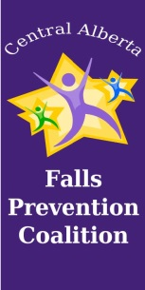

**This workshop is designed for service providers who work with seniors in the community or in a care facility. There will be speakers on a variety of topics as well as community partner display tables. Workshop is brought to you by Central Alberta Falls Prevention Coalition in partnership with Red Deer County**

TARGET

SENIOR FALLS